Communication in the Civil War (2 Day Lesson)

Minnesota K-12 or District Standards:
Regional tensions around economic development, slavery, territorial expansion and governance resulted in a civil war and a period of Reconstruction that led to the abolition of slavery, a more powerful federal government, a renewed push into indigenous nations’ territory, and continuing conflict over racial relations. (Civil War and Reconstruction: 1850—1877)

Minnesota K-12 Benchmark:
(9.4.4.19.3) Describe the course of the Civil War, identifying key political and military leaders, issues, events and turning points on battlefields and home fronts, in South, North and West.

Rationale:
These lessons will help students understand that communication was very important during the civil war, but also very different for different situations. Letters would be used to inform families and friends about the soldiers’ condition in the war, while telegrams were used to relay messages from battles or giving information on the enemy so that it could be used to help win the war. The lessons will compare these types of communication to explain its importance, and communication from the civil war era will be compared to communication today, so that students can understand the difficulties of sending information during this time.

Objectives:
The main goals of these lessons are to explain the importance of communication during the civil war. The lessons will also explain the difference between different kinds of communication as well as the differences between communication from the 1800s and communication today.
- TSWBAT identify the different types of communication that was used during the civil war
- TSWBAT explain why communication was so important during the civil war
- TSWBAT analyze the similarities and differences between communication then, and communication today, as well as to see the difficulties that came with communication during the civil war

Activities:
- letter reading activity
  - Class discussion of three different Abbott letters
  - In-class letter analysis worksheets (in lesson plan)
  - Short lecture on differences between communication then and now
- telegram activity
  - Short lecture on telegrams usage in Civil War
  - Decoding telegrams
  - Class discussion

Materials:
- Abbott Letters (link connected to lesson plan)
- Letter Analysis worksheet (at end of lesson plan)
- Telegram examples and keys
- Morse Code Key

Academic Language:
- Communication
- letters
- telegrams

Assessment: Day 1
- Evaluate the Primary Source Worksheet from the second reading (Isaac Mark Abbott letter to sister Lydia, 04-24-1863) to see if students understood the importance of personal letters during the war

Time:
Day 1
Activity | Purpose | Est. Time (50 min)
Full class letter analysis | Allows the class to work together to understand how to analyze a letter before they work on analyzing letters on their own | 15 min.
Individual/group letter analysis | Gives students the ability to analyze letters on their own before discussing their significance in groups | 20 min.
Comparison of Letter then and now (lecture/ class discussion) | Allows students to see comparisons in the process of communication and significance of communication from the Civil War to today | 15 min.

Day 2
Activity | Purpose | Est. Time (50 min.)
Short Class Lecture | Explains the purposes of telegrams during the war | 15 min.
Telegram activity | Allows students to get first-hand experience with telegrams to see how difficult they are to use | 20 min.
Class Discussion: Telegrams vs. Personal letters | This class discussion will help students understand the differences between personal letters and telegrams during the Civil War and why both were significant | 15 min.

Interactive Lesson Plan Outline (Day 1)
- Short Introduction to civil war personal letters and to Isaac Mark Abbott (description can be found on the same web page as the letter)
- Read the first letter by Isaac Mark Abbott as a class (Isaac Mark Abbott letter to sister Becca, 11-22-1863) http://digitalhorizonsonline.org/cdm/compoundobject/collection/cord-dfah/id/162/rec/49
  - Work with students to answer the questions on the primary source worksheet (see below). Help students clear up any confusion that they might have about the letter (such as who wrote the letter or defining terms that the students may not understand).
- It is recommended to split the students into groups to read the second letter by Isaac Mark Abbott (Isaac Mark Abbott letter to sister Lydia, 04-24-1863) (*Note: You can decide whether the students read the letter individually or as a group). http://digitalhorizonsonline.org/cdm/compoundobject/collection/cord-dfah/id/329/rec/55
  - After the students have read the letter, they should work in groups to answer the questions on the Primary Source Worksheet
- Communication then and now
  - Have students make connections between communication with friends/family during the civil war to today (this could easily be done with a Venn Diagram).

Interactive Lesson Plan (Day 2)
- Ideas that students should learn during this lesson:
  - Lincoln’s need to use coded messages
    - Lincoln always saw the telegram as a military tool
    - Lincoln would constantly be near a telegram station day and night to receive or send messages
  - What are telegrams? How were they used?
    - Telegrams are messages that were used to pass information across far distances in a short time. They would be sent by operators through electrical wires that produced a series of dots and dashes, which could be listened to by a different operator across far distances.
  - What is Morse Code?
    - A series of electrical dots and dashes that could be used to form letters and words.
  - Why were telegrams used?
    - Telegrams were used because they were a faster way to transport information from a farther distance and they allowed messages to be more secretive
  - Why / how were telegrams coded?
    - Important messages we encoded so that they could not be intercepted by the enemy.
    - Operators would send messages coded and then the receiving operator would have different key words to decipher the coded messages. There were different key codes depending on the operating station and the subject of the message.

- Morse Code and/or Vigenere Cipher activity
  - To show students the complexity of sending and deciphering coded messages in the war, allow the students to send messages to someone else in the class in Morse Code and allow them to decipher them. Messages can also be made more challenging by using messages you provide to students.
  - Allow students to try decoding messages on their own. Hand out sheet with three different coded messages, then place three different key cards at different parts of the classroom, these can be known as military outposts. Have students go around to decipher the messages while they travel to the different stations. You do not need to allow extra time to allow students to finish all of the messages; in fact, you want some of them to fail at finishing all of them to show the amount of difficulty of these codes. The goal is to have them succeed and fail at finding the right key code to decipher their messages. (examples will be provided below) (NOTE* if time constraints are an issues, students can just do the one of the activities)

- Class Discussion
  - Ask students what they thought about decoding the messages (was it hard, did it take a long time, etc.)
  - Discuss why messages were coded in the war and what types of messages might be coded compared to others.
  - Talk with students about the difference between the personal war letters that were talked about in the first lesson and the coded war messages (subjects to talk about: why were personal letters not coded, what information was written in both types of communication, how were the types of communication different, ect.) The goal is to establish different ways in which communication was important during the war, for soldiers, military strategists, as well as those on the home front

Middle School Lesson Adaptation:
- For the first day, it is recommended that the class does not analyze the second letter and that the primary source worksheet not be used (although you can ask specific questions from the worksheet if so desired).
- For the second day, it is recommended that you not use the class discussion on comparing the past to the present. The other activities will take up most of the class period and this day would be better used as an example for types of communication.

Name: ______________________

Primary Source Worksheet

1. Who wrote this document?

2. Who was the document made for?

3. When was the document written?

4. Name 3 important points made in the document

5. Write down any words or phrases that do not make sense to you, as well as a possible meaning for the words/phrases

6. Why do you think the author wrote this document?

Morse Code Key
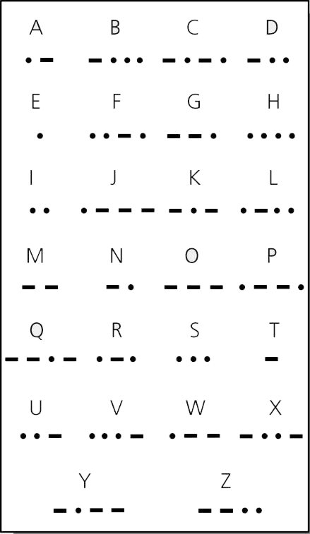

Example Sentence: I like flags
** / *-** ** -*- * / **-* *-** *- --* ***

Vigenere Cipher Table

Use Key Code Letters Horizontally →
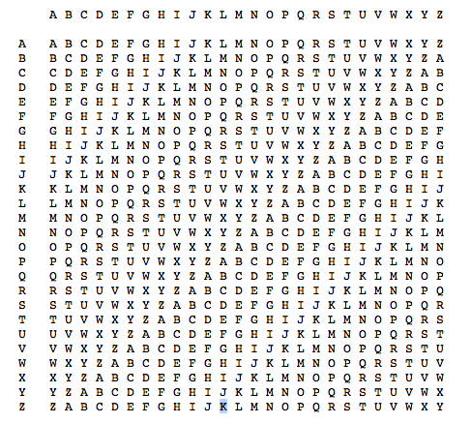
↑ Use Coded Text Letters Vertically

Key Example: Flag Text Example: VBELDRA (america)

Directions:
- Take the first letter of the key code (“F”) on the horizontal line, then take the first letter of the coded message (“V”) on the vertical line. Where they intersect will be the first letter of the decoded text (“A”)
- Continue this process with the second, third, and fourth letters, etc. When you reach the end of the key code (“G”), then go back to the first letter of the key code (“F”)
- When the final coded letter is decoded, you will have the full text!

Flag

Train Car

Liberty

Vigenere Cipher Assignment (for teachers use)

Code #1

Code Key: Liberty

Decoded Message: Rebels heading north, prepare for attack

Coded Message:

GWAAUZ JTSCEEN PDJSD YYGESQA OVT PLSWLR

Code #2

Code Key: Train Car

Decoded Message: Medical supplies are heading to your location

Coded Message:

TNDAPYL BBYPDVCS JYN HWNBIWN CO QBSR UVLALVMN

Code #3

Code Key: Flag

Decoded Message: Gen. Grant orders full halt of soldiers

Coded Message:

BTN AMPNN JGDYMH FOGA HUGI OZ NDLXDTRM

Name: ____________________

Decipher the Code!

Code #1: GWAAUZ JTSCEEN PDJSD YYGESQA OVT PLSWLR

___ ___ ___ ___ ___ ___ ___ ___ ___ ___ ___ ___ ___ ___ ___ ___ ___ ___

___ ___ ___ ___ ___ ___ ___ ___ ___ ___ ___ ___ ___ ___ ___ ___

Code #2: TNDAPYL BBYPDVCS JYN HWNBIWN CO QBSR UVLALVMN

___ ___ ___ ___ ___ ___ ___ ___ ___ ___ ___ ___ ___ ____ ____

___ ___ ___ ___ ___ ___ ___ ___ ___ ___ ___ ___ ___ ___ ___ ___

___ ___ ___ ___ ___ ___ ___ ___

Code #3: BTN AMPNN JGDYMH FOGA HUGI OZ NDLXDTRM

___ ___ ___ ___ ___ ___ ___ ___ ___ ___ ___ ___ ___ ___

___ ___ ___ ___ ___ ___ ___ ___ ___ ___ ___ ___ ___ ___ ___ ___ ___ ___

Other Resources

Allen, Thomas B., and Roger MacBride Allen. "Rails & Wires at War." Mr. Lincoln's High-tech War: How the North Used the Telegraph, Railroads, Surveillance Balloons, Ironclads, High-powered Weapons, and More to Win the Civil War. Washington, D.C.: National Geographic, 2009. Print.
"Hila Code Key." Hila Code Key. Web. 14 Mar. 2015. <http://hila.webcentre.ca/projects/morse_code/>.
Jones, Terry. "The Codes of War." The New York Times 14 Mar. 2013. The New York Times. Web. 10 Mar. 2015. <http://opinionator.blogs.nytimes.com/2013/03/14/the-codes-of-war/?_r=0>.

