Reasons to Fight in the Civil War

Minnesota K-12 or District Standards:
Regional tensions around economic development, slavery, territorial expansion and governance resulted in a civil war and a period of Reconstruction that led to the abolition of slavery, a more powerful federal government, a renewed push into indigenous nations’ territory, and continuing conflict over racial relations. (Civil War and Reconstruction: 1850—1877)

Minnesota K-12 Benchmark:
(9.4.4.19.2) Describe the recurring antebellum debates over slavery and state’s rights, popular sovereignty, and political compromise; analyze how the American political system broke down in the 1850s and culminated in southern Secession, the establishment of the Confederate States of America and the Union response.

Rationale:
This lesson will help students understand the Union citizens reasoning for supporting the war effort. While many classroom studies focus on the Confederate’s reasons for Secession and declaration of war, there is usually not much taught about the reason why Union citizens supported the war effort (ex: soldiers volunteering for war). This lesson will examine different artifacts of the Civil war in order to analyze the reason why the Union supported the war effort.

Objectives:
The purpose of this lesson is to explain the Union’s reasons for joining the Civil War.
- TSWBAT analyze the different artifacts in order to explain the Union’s patriotism.
- TSWBAT explain how the Union citizens’ war efforts were used to reform the Union and to compel the ideology of emancipation.

Activities:
- Battle Hymn of the Republic analysis
- Presentation
  - Civil War propaganda
- Abbott letter examples / analysis

Materials:
- “Battle Hymn of the Republic” (will need lyrics, actual song is optional)
- Civil War propaganda posters
- Abbott Letters

Academic Language:
- Patriotism: Devoted love, support, and defense of one’s nation; national loyalty
- Propaganda: Information, ideas, or rumors deliberately spread widely to help or harm a person, group, movement, institution, nation, etc.
- Copperhead: Vocal faction of the North who opposed the Civil War
- Butternut: Northerners who supported the Southern cause during the Civil War
- Secesher: A sympathizer of the Confederacy
- Bushwhacking: A form of guerilla warfare

Assessment:
- Primary Source Worksheet

Time:

Activity | Purpose | Est. Time (50 min)
Song analysis | Looking at these iconic songs will allow students to recognize that Civil War propaganda can be seen even today and was widely used during the war. | 10 min.
Class lecture/ poster examples | The lecture and poster will give more context the types of propaganda that were used during the war as well as why the Union was dedicated to the war effort. | 20 min.
Abbott letter analysis | These letters show a personal account about the opinions of a Union soldier on both the Union’s war effort as well as the Union’s opinion of the Confederacy. | 20 min.

Interactive Lesson Plan Outline:
- Open the lesson with some example songs that were used in the Civil War to rally Union citizens; some good example are “The Battle Hymn of the Republic” and “The Battle Cry for Freedom” (Union Version)
- You can choose to have the students listen to the songs or just look at the lyrics, but as a class you should analyze some of the lines to show some of the reasons why the Union participated in the war.

- Brief discussion of Union cooperation and poster examples
  - Civil war posters (go over these images as a class and ask students what their first impressions of the posters, then discuss the meaning of the posters).
    - Image #1 (see below)
      - This first image shows a recruitment poster with lady liberty and the words ‘the nation must be saved’. The poster expresses a sense of Union patriotism that was used to rally people to join the war effort. ‘The nation must be saved’ line demonstrates the fear that southern ideology might spread, especially to the newly developing West.
    - Image #2 (See below)
      - This recruitment poster is much more violent than the other one as it shows a complete defeat of the Confederacy. This could have been made after the events at Bull Run, which could mean that this poster represents the ideas of complete victory over South, as seen by the Union soldier standing over the dead Confederate soldier.
    - Image #3 (See below)
      - This image show a different way the inspired people to become involved in the northern war effort. This poster shows the cruelties of slavery with the image of a mother being separated from his mother. This poster was probably used to demonize the enemy as well as to sympathize with the ideas of emancipating the slaves.
- Abbott letter excerpts
  - The students can be separated into groups to analyze the following excerpts. Before they read the letters, it is recommended that you tell them a little bit about the author of these letters (description provided on the website with the letters). As the students look over the excerpts they should fill out the primary source worksheet provided below. After the students analyze the letters, talk as a whole class about what they discovered and how that correlates to what they have learned in class.
  - Letter except #1 (Isaac Mark Abbott letter to brother Roe Abbott, 07-28-1864) http://digitalhorizonsonline.org/cdm/compoundobject/collection/cord-dfah/id/245/rec/14
    - You wanted to know if there was much politics with us. There is considerable gassing about it but we are mostly of one mind about who ought to be president for the coming four years and if Co. K should receive the invitations + + choose whom ye will serve, there would go up almost an universal shout for Lincoln! & Johnson! There is not a Freemont man in the Co. and I think but very few in the reg’t, although if the Chicago Convention nominates anyone but a regular Copperhead for the office, I expect there will be a great many of the Democrats who will vote for him! For it is hard for them to give up the old party even for the good of the country. There has been talk about our getting to home to vote but I think that it is all papycock. But I would have no objections for we would have a he old time if we did get home. And the betternuts & copperheads would have to lay low & keep dark during our stay. [...] Here’s success to the draft! The election of Old Abe! And death to traitors and the Southern Confederacy!
Ike
    - Notes:
      - Copperhead: Vocal faction of the North who opposed the Civil War
      - Betternuts (or Butternuts): Northerners who supported the Southern cause during the Civil War
  - Letter excerpt #2 (Isaac Mark Abbott letter to brother Roe Abbott, 8-19-1864) http://digitalhorizonsonline.org/cdm/compoundobject/collection/cord-dfah/id/133/rec/16
    - Once place where it was torn up, there was an old secesher living in a nice house. Our men searched the place & found several guns and a lot of cartridges in the house so Gen’l Studman ordered it to be burned and there was a detail went up and burned it & then barn and all the out-houses to the ground. I tell you looked pretty hard to see a family burned out of house & home but that appears to be the only way to dry up their bushwhacking. And perhaps they will find out after a while that Uncle Sam is determined to put down their rebellion regardless of the cost, and they will be able to see more clearly what it is going to cost them to experiment with their Southern Confederacy and I think that where the torch can be used to good advantage towards putting down the rebellion, that it is perfectly right to use it. And there is nothing that will make them sick of war sooner than to take it right to their homes and give them to understand that the government is to be respected about everything else and that if it is necessary (in order to subdue them) to wrap the whole country in flames, that it will be done!
    - Secesher: A sympathizer of the Confederacy
    - Bushwhacking: A form of guerilla warfare
  - Letter excerpt #3 (Isaac Mark Abbott letter to family, 11-21-1863
    - I think that Abraham Lincoln will yet be president over every state in the Union, and the stars and stripes will float all over this once happy land. And we will have a better government than we had before. It may cost the blood of many a brave man, but we had better half of us die than see this government ruined. I think there will be a hard fight here and if we can whip them out right good it will about end the thing.

Middle School Lesson Adaptation:
- Leave out the poster analysis because that will go into too much detail and consume too much time
- For the letter analysis, it is recommended that you only evaluate the first letter, this is essentially due to time constraints and giving the students more time to analyze the first letter

“The Battle Hymn of the Republic” Lyrics

Mine eyes have seen the glory
Of the coming of the Lord
He is trampling out the vintage
Where the grapes of wrath are stored
He has loosed the fateful lightening
Of His terrible swift sword
His truth is marching on

I have seen him in the watch-fires
Of a hundred circling camps
They have builded him an altar
In the evening dews and damps
I can read his righteous sentence
By the dim and flaring lamps
His day is marching on

I have read a fiery gospel
Writ in burnish'd rows of steel
As ye deal with my condemners
So with you my grace shall deal
Let the hero, born of woman
Crush the serpent with his heel
Since God is marching on

Glory, glory, hallelujah
Glory, glory, hallelujah
Glory, glory, hallelujah
Our God is marching on

He has sounded form the trumpet
That shall never call retreat
He is sifting out the hearts of men
Before His judgment-seat
Oh, be swift, my soul
To answer him be jubilant, my feet
Our God is marching on

Glory, glory, hallelujah
Glory, glory, hallelujah
Glory, glory, hallelujah
Our God is marching on

In the beauty of the lilies
Christ was born across the sea
With a glory in his bosom
That transfigures you and me
As he died to make men holy
Let us live to make men free
While God is marching on

Glory, glory, hallelujah
Glory, glory, hallelujah
Glory, glory, hallelujah
Our God is marching on

“The Battle Cry for Freedom” (Union Version) Lyrics
Yes we’ll rally round the flag, boys, we’ll rally once again,
Shouting the battle cry of freedom, We will rally from the hillside, we’ll gather from the plain, Shouting the battle cry of freedom!

The Union forever! Hurrah, boys, hurrah!
Down with the traitor, up with the star;
While we rally round the flag, boys, rally once again,
Shouting the battle cry of freedom!

We are springing to the call with a million freemen more,
Shouting the battle cry of freedom! And we’ll fill our vacant ranks of our brothers gone before, Shouting the battle cry of freedom!

The Union forever! Hurrah, boys, hurrah!
Down with the traitor, up with the star;
While we rally round the flag, boys, rally once again,
Shouting the battle cry of freedom!

We will welcome to our numbers the loyal, true and brave,
Shouting the battle cry of freedom!
And although he may be poor, he shall never be a slave,
Shouting the battle cry of freedom!

The Union forever! Hurrah, boys, hurrah!
Down with the traitor, up with the star;
While we rally round the flag, boys, rally once again,
Shouting the battle cry of freedom!

So we’re springing to the call from the East and from the West,
Shouting the battle cry of freedom!
And we’ll hurl the rebel crew from the land we love best,
Shouting the battle cry of freedom!

The Union forever! Hurrah, boys, hurrah!
Down with the traitor, up with the star;
While we rally round the flag, boys, rally once again,
Shouting the battle cry of freedom!

Poster Image #1

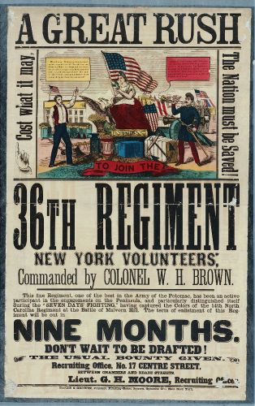

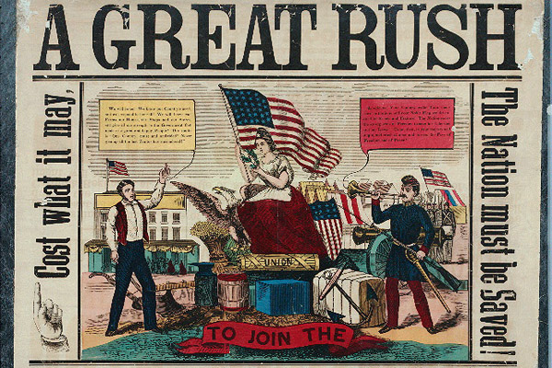

http://www.theatlantic.com/national/archive/2011/10/civil-war-recruitment-posters/247420/#slide2

Poster Image #2

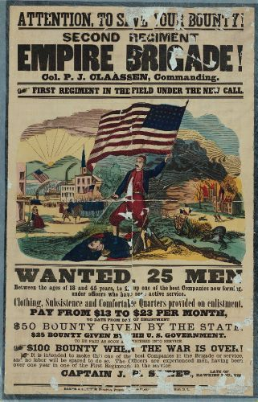
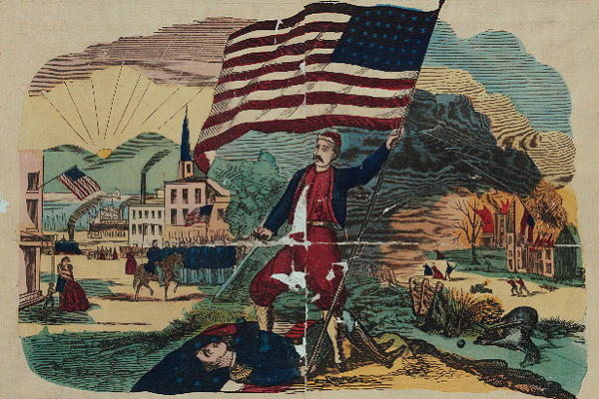

http://www.theatlantic.com/national/archive/2011/10/civil-war-recruitment-posters/247420/#slide7

Poster Image #3
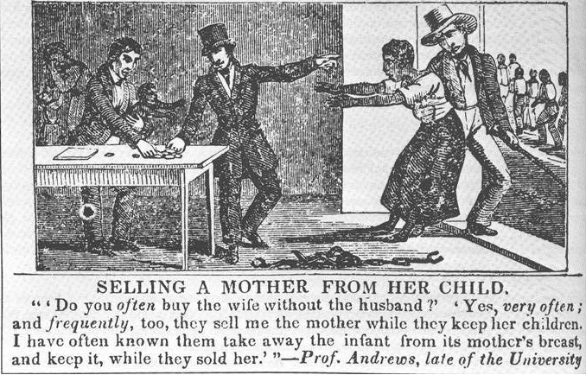
https://ideologicalart.wordpress.com/war/

Name: ______________________

Primary Source Worksheet

1. Who wrote this document?

2. Who was the document made for?

3. When was the document written?

4. Name 3 important points made in the document:

5. Write down any words or phrases that do not make sense to you, as well as a possible meaning for the words/phrases

6. Why do you think the author wrote this document?

Sources
- Abbott, Issac. Issac Mark Abbott Letters. Digital image. Digital Horizons. 1 Jan. 1864. Web.
- "American Civil War." Visual Propaganda Ideology in Art. 12 Dec. 2011. Web. 21 Apr. 2015. <https://ideologicalart.wordpress.com/war/>.
- Resnick, Brian. "Civil War Recruitment Posters." The Atlantic. Atlantic Media Company, 28 Oct. 2011. Web. 21 Apr. 2015. <http://www.theatlantic.com/national/archive/2011/10/civil-war-recruitment-posters/247420/#slide7>.
- Tierney, Dominic. How We Fight: Crusades, Quagmires, and the American Way of War. 2010. Print.

